**Accessibility Report**

**Approach to conformance testing:**

Conformance testing refers to the process of verifying whether a website or application meets the standards and guidelines for accessibility. These standards are often defined by the Web Content Accessibility Guidelines (WCAG), which is a set of recommendations for making web content more accessible to people with disabilities.

I have approached conformance testing through three distinct methods:

Firstly, automated testing utilizes software tools, like WAVE, Lighthouse, and axe, to systematically scan and test websites or applications for accessibility issues. These tools efficiently detect problems such as missing alt text, insufficient color contrast, and incorrect HTML structure.

Secondly, manual testing engages a human tester in navigating and interacting with the website or application to identify accessibility issues. This hands-on approach can capture nuances that automated tools might overlook, including aspects like logical tab order, keyboard accessibility, and meaningful link text.

Lastly, the checklist approach involves using a comprehensive checklist of accessibility criteria, such as the WCAG guidelines. By meticulously verifying that the website or application meets each criterion, this method ensures a systematic and thorough assessment of all aspects of accessibility.

**Test results and Recommendations:**

**Accessibility issues and warnings were identified on the home.html page as follows:**

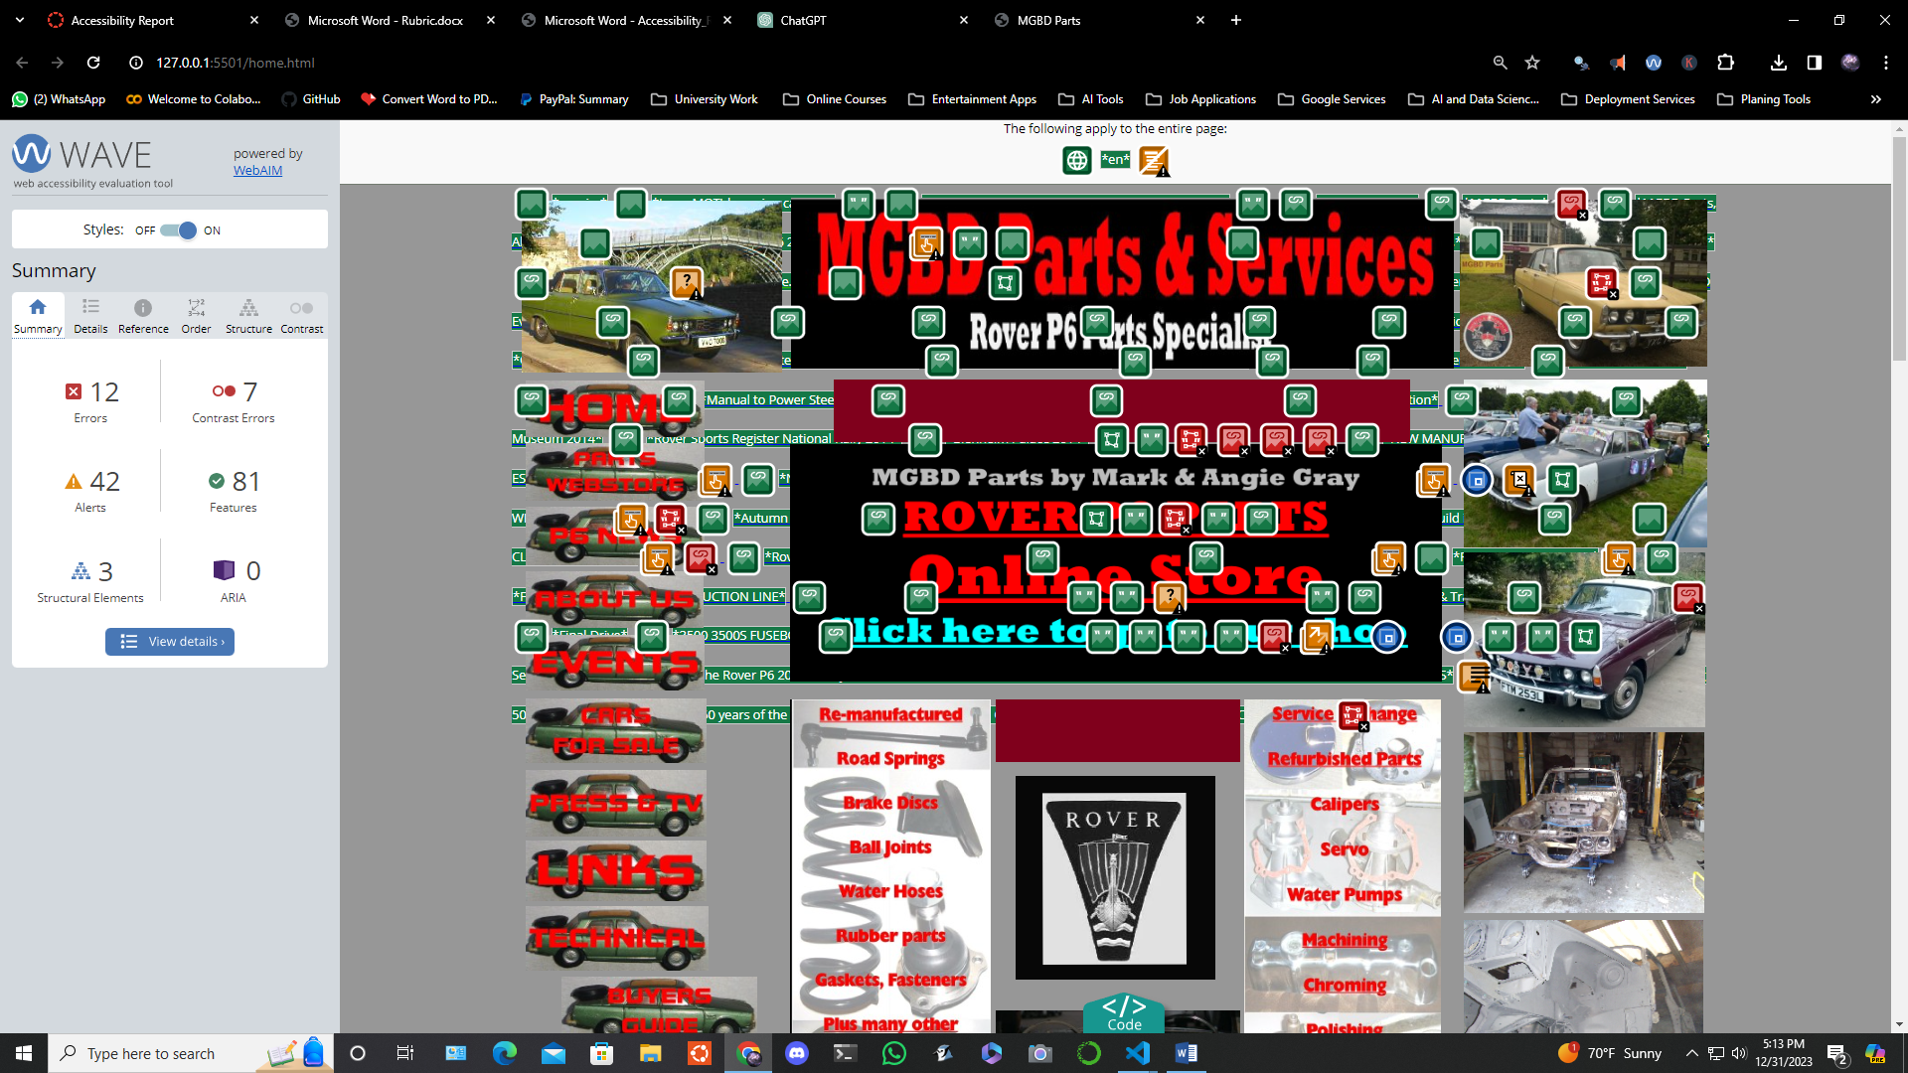

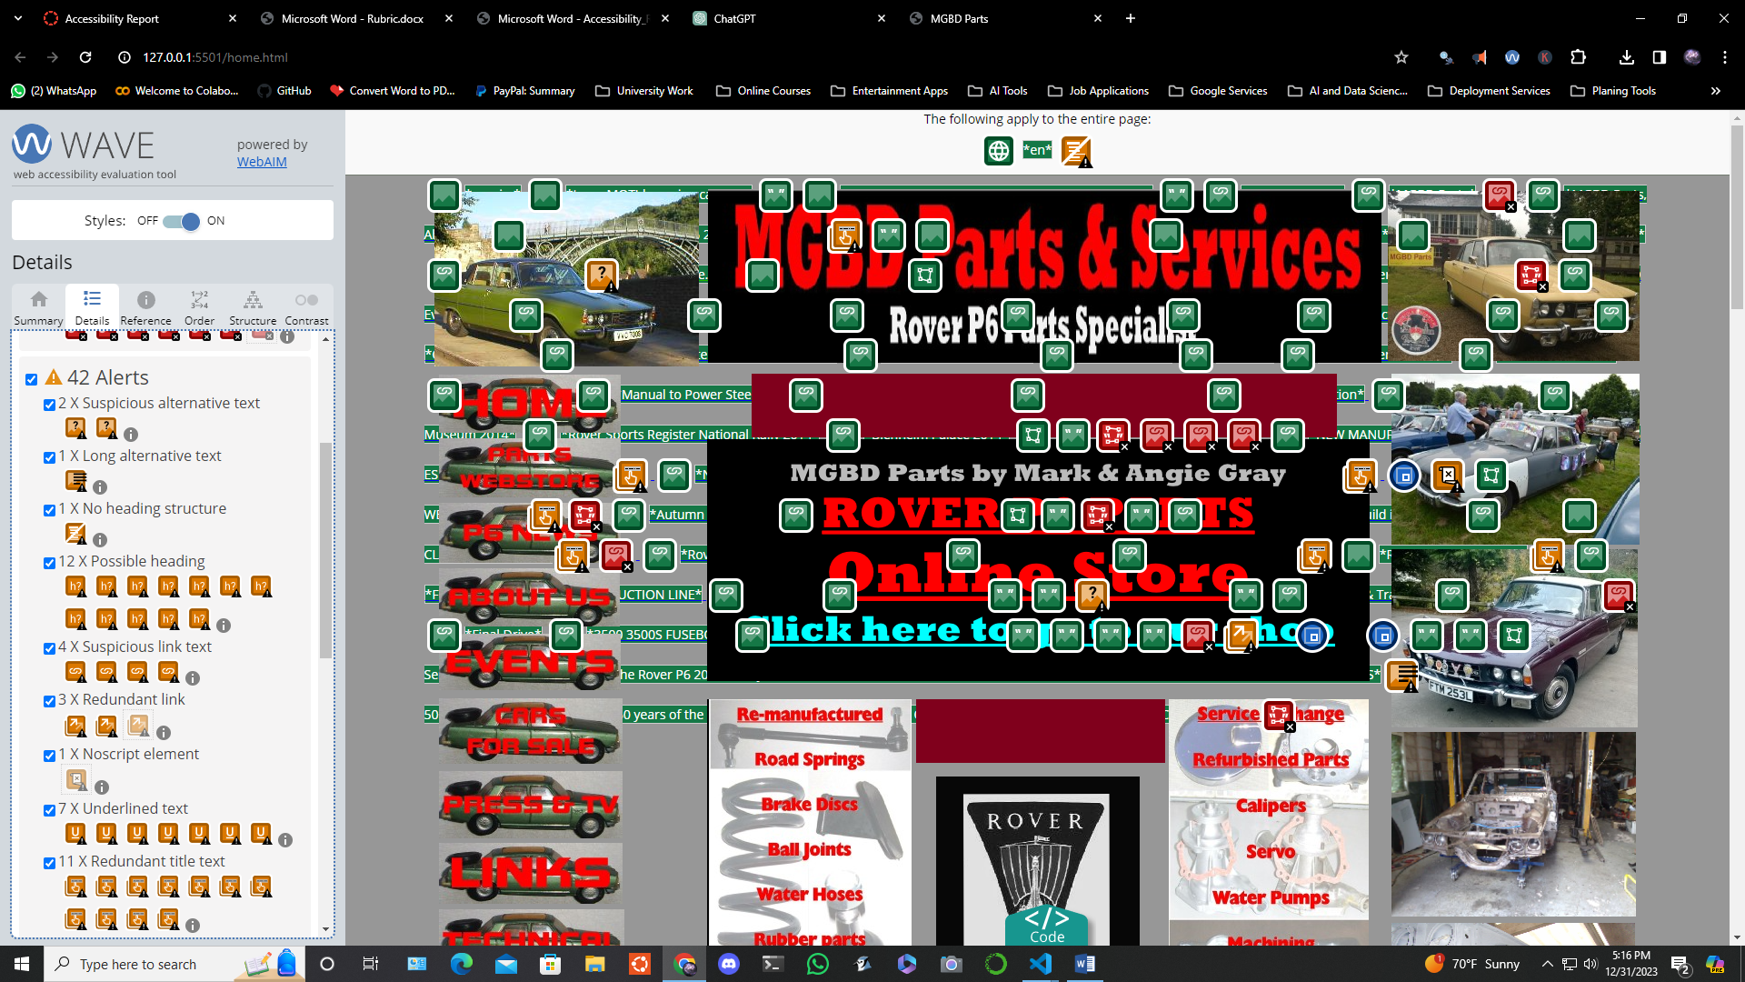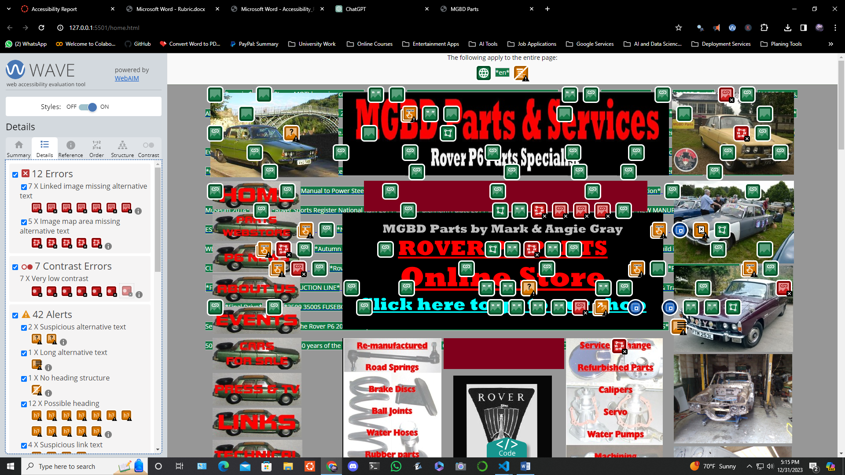

**12 Errors:**

**7 X Linked image missing alternative text:**

This signifies that an image lacks alternative text, resulting in an empty link. It is crucial to provide descriptive alternative text for images within links, especially when the link contains no textual content. Without alternative text, screen readers cannot convey the function of the link to users. To address this, add appropriate alternative text that accurately describes the content of the image and/or the function of the link.

**5 X Image map area missing alternative text:**

In this case, alternative text is absent for an image map area (hot spot). Image map areas or clickable hot spots offer essential functionality, and providing alternative text is essential for screen reader users or when images are not available. To resolve this issue, add descriptive alt attribute values to each area element. Additionally, ensure the logical and intuitive ordering of area elements in the code.

**7 Contrast Errors:**

**7 X Very low contrast:**

This indicates very low contrast between text and background colors, which is crucial for users, particularly those with low vision. To remedy this, increase the contrast between the foreground (text) color and the background color. It's important to note that large text requires less contrast than smaller text.

**42 Alerts:**

**2 X Suspicious alternative text:**

This points to potentially insufficient or extraneous information in alternative text for images. It's essential to ensure that alternative text provides equivalent information to the image content. Avoid using generic alternative text like "image of..." and make sure it succinctly represents the image's content and function.

**1 X Long alternative text:**

A warning is raised for images with very long alternative text. Alternative text should be concise and descriptive. Lengthy alternative text (over 100 characters) may indicate the inclusion of extraneous content. To address this, ensure the alternative text is succinct and describes the content and function of the image.

**1 X No heading structure:**

This indicates the absence of headings, which are crucial for document structure and navigation for assistive technology users. To rectify this, provide a clear and consistent heading structure, including at least one <h1> and sub-headings as appropriate.

**12 X Possible heading:**

This alerts that text appears to be a heading but lacks a heading element. For sections posing as headings, use appropriate heading elements (<h1>-<h6>) to maintain document structure and aid assistive technology users.

**4 X Suspicious link text:**

Links with ambiguous or extraneous text may cause confusion, especially when read out of context. Rephrase link text to be more descriptive of its destination, and eliminate any extraneous text like "click here."

**3 X Redundant link:**

Adjacent links going to the same URL can result in additional navigation and repetition for users. If possible, combine redundant links into one link, removing any redundant text or alternative text.

**1 X Noscript element:**

The presence of a <noscript> element is flagged. Ensure scripted content is accessible, as <noscript> cannot be relied upon to provide an accessible version when JavaScript is disabled.

**7 X Underlined text:**

Underlined text typically indicates linked text. Consider removing underlines from non-link text unless there is a distinct need for it. Use other styling options (e.g., bold or italics) to differentiate non-link text.

**11 X Redundant title text:**

Title attribute text identical to text or alternative text is flagged. The title attribute is meant for advisory information and should not duplicate other content. Modify or remove redundant title text to provide unique advisory information. Note that title text may not be read by a screen reader and is typically inaccessible to sighted keyboard users.

**Accessibility issues and warnings were identified on the shop.html page as follows:**

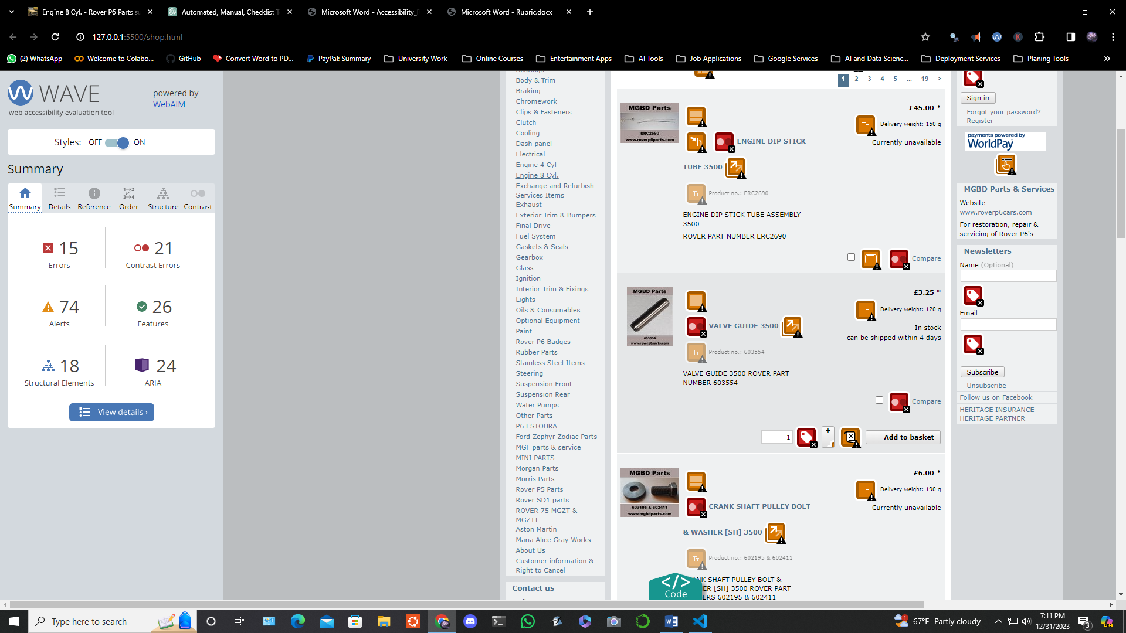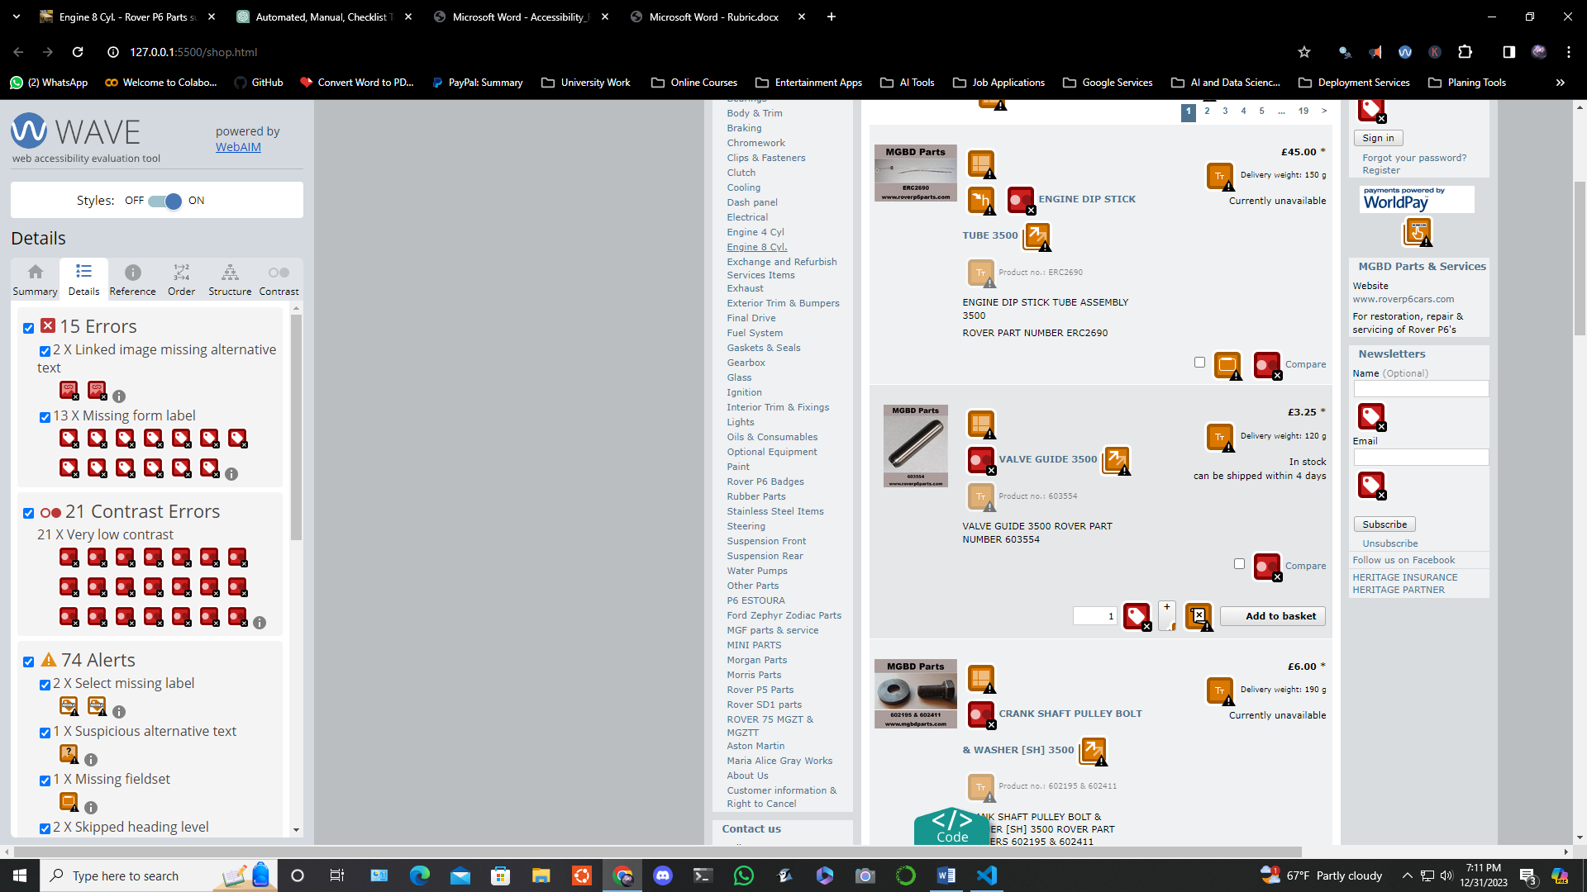

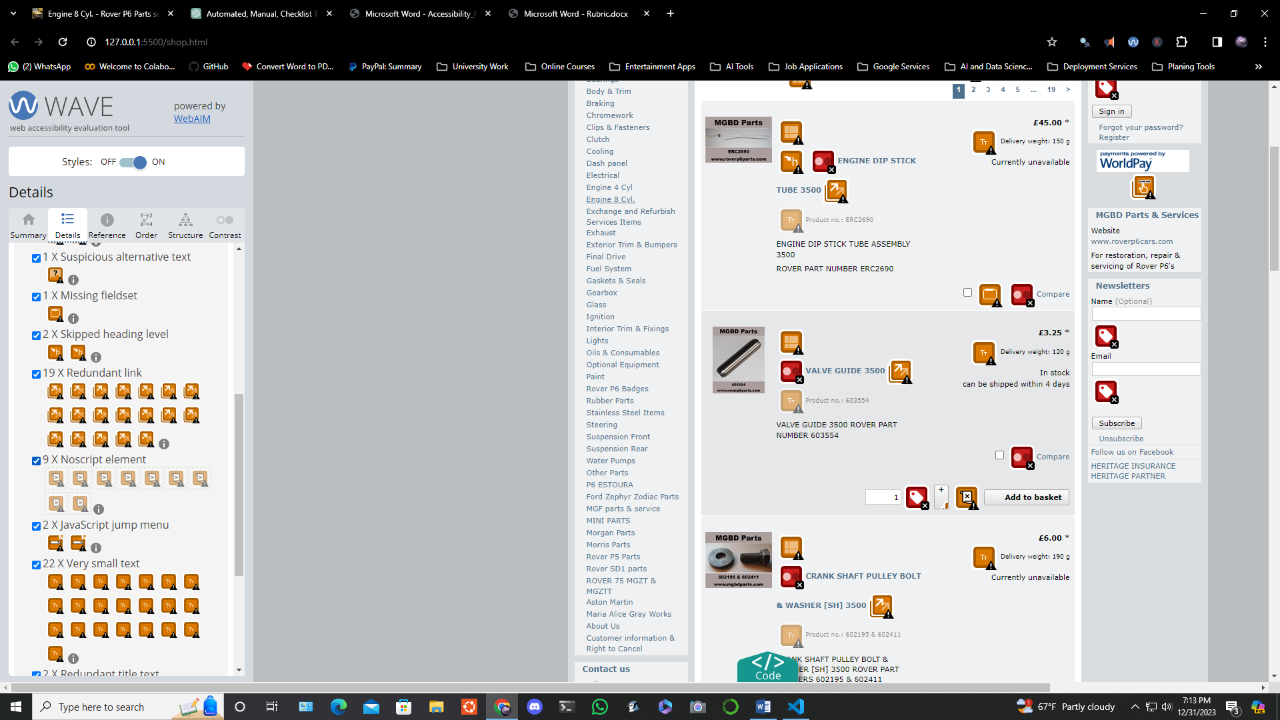

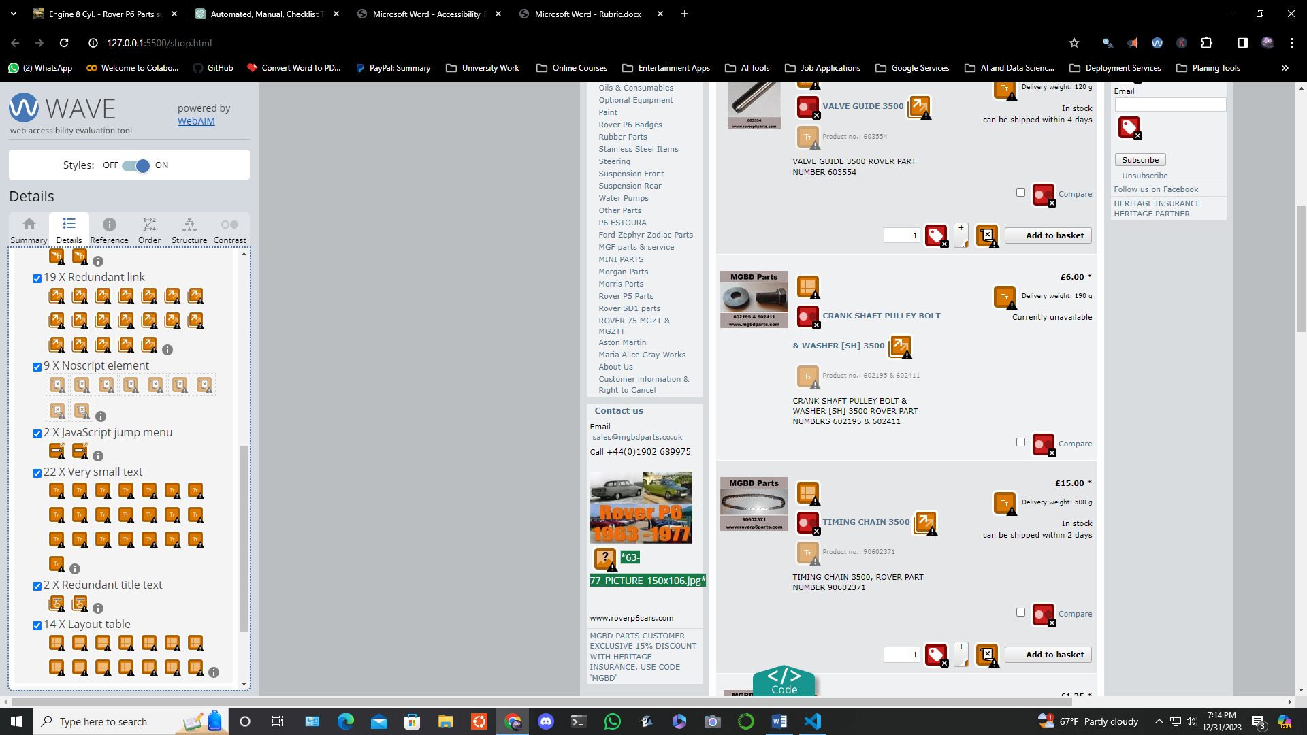

**15 Errors:**

**2 X Linked image missing alternative text:**

This indicates that certain images lack alternative text, resulting in empty links. It is crucial to provide descriptive alternative text for images within links, especially when the link contains no textual content. Without alternative text, screen readers cannot convey the function of the link to users. To address this, add appropriate alternative text that accurately describes the content of the image and/or the function of the link.

**13 X Missing form label:**

This signifies that a form control lacks a corresponding label. This omission can hinder screen reader users' understanding of the form control's purpose. Form labels also enhance visual descriptions and provide larger clickable targets for form controls. To fix this, associate visible label text with its respective form control using the <label> element. If no visible label exists, provide an associated label, add a descriptive title attribute to the form control, or reference the label(s) using aria-labeled. Note that labels are not required for certain form controls.

**22 Contrast Errors:**

**21 X Very low contrast:**

This flags very low contrast between text and background colors, particularly impactful for users, especially those with low vision. To rectify this, increase the contrast between the foreground (text) color and the background color. It's important to note that larger text requires less contrast than smaller text.

**74 Alerts:**

**2 X Select missing label:**

A select element lacking an associated label can impact users, especially those relying on screen readers. To resolve this, ensure that the default option of the select menu clearly presents its purpose. If visible label text exists, associate it with the select menu.

**1 X Suspicious alternative text:**

This points to potentially insufficient or extraneous information in alternative text for images. It's crucial to ensure that alternative text provides equivalent information to the image content. Avoid generic alternative text like "image of..." and use succinct yet equivalent alternatives.

**1 X Missing fieldset:**

A group of checkboxes or radio buttons lacking a fieldset can hinder understanding. Fieldsets provide visual and structural grouping, especially when a higher-level description (legend) is necessary. To address this, mark up the group within a fieldset and include a legend element.

**2 X Skipped heading level:**

Skipping heading levels can confuse users relying on assistive technology. Restructure document headings to ensure a logical hierarchy.

**19 X Redundant link:**

Adjacent links going to the same URL result in additional navigation and repetition for users. If possible, combine redundant links into one link, removing any redundant text or alternative text.

**9 X Noscript element:**

The presence of a <noscript> element is flagged. Ensure scripted content is accessible, as <noscript> cannot be relied upon to provide an accessible version when JavaScript is disabled.

**2 X JavaScript jump menu:**

A JavaScript jump menu, triggering a page change with the onchange event, may hinder keyboard navigation. If applicable, eliminate the JavaScript jump menu and allow users to change the select menu, activating an adjacent button to trigger the new page.

**22 X Very small text:**

Very small text poses readability challenges, particularly for those with low vision. Increase text size for better readability.

**2 X Redundant title text:**

Title attribute text identical to text or alternative text is flagged. Modify or remove redundant title text to provide unique advisory information.

**14 X Layout table:**

Presence of layout tables, used for visual positioning, can introduce reading and navigation order issues. Replace layout tables with appropriate HTML elements and CSS for visual presentation. If a layout table remains, ensure logical reading and navigation order, and give it role="presentation" to prevent identification as a data table by screen readers.